Project Design Phase-II

Data Flow Diagram & User Stories

|  |  |
| --- | --- |
| Date | 31 January 2025 |
| Team ID | PNT2025TMID02539 |
| Project Name | Global Food Production trends and Analysis:A  Comprehensive Study from 1961 to 2023 Using Power BI |
| Maximum Marks | 4 Marks |

Data Flow Diagrams:

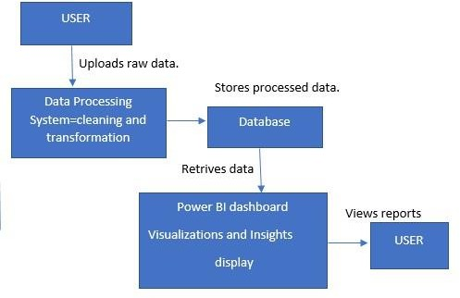Level 0 Data Flow Diagram (DFD) for Global Food Production Trends

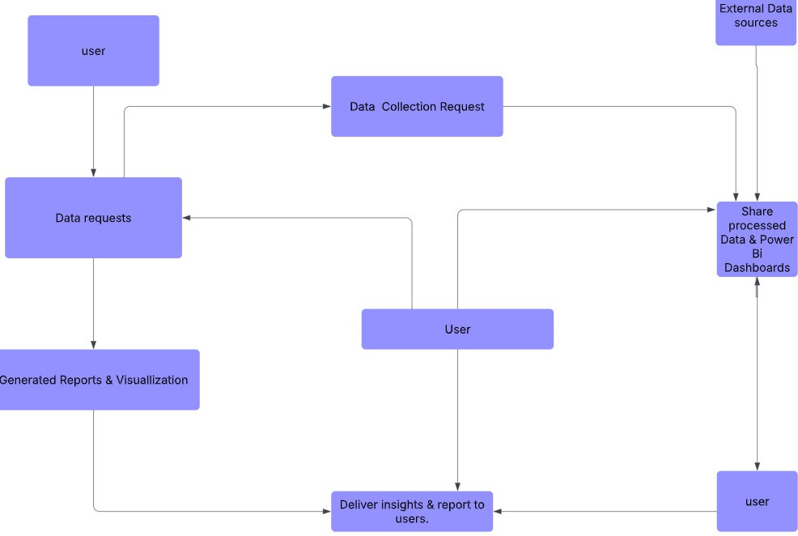

**And Analysis:**

|  |  |  |  |  |  |  |
| --- | --- | --- | --- | --- | --- | --- |
| **User Type** | **Functional Requirement (Epic)** | **User Story Number** | **User Story / Task** | **Acceptance criteria** | **Priority** | **Release** |
| Data Analyst | Data Collection | USN-1 | As a data analyst, I can collect and load global  food production datasets 1961 to 2023 | Data is successfully stored  in the database. | High | Sprint-1 |
| Data Analyst | Data Cleaning | USN-2 | As a data analyst, I can clean and preprocess  the dataset to remove inconsistencies. | Data has no missing or  inconsistent values. | High | Sprint-1 |
| BI Developer | Data  Transformation | USN-3 | As a BI developer, I can normalize and merge  datasets for analysis. | Data is formatted  correctly for visualization. | Medium | Sprint-2 |
| BI Developer | Visualization | USN-4 | As a BI developer, I can create dashboards to  show food production trends. | Dashboard displays  accurate trend analysis. | High | Sprint-3 |
| Researcher | Insights & Reporting | USN-5 | As a researcher, I can analyze food production trends by region and crop type. | Report includes  correlations and key insights. | Medium | Sprint-4 |
| End User | Report Access | USN-6 | As an end user, I can access and download the final reports on food production. | Users can download reports in PDF format. | High | Sprint-4 |